CHAPTER III

FORMS AND DATA ANALYSIS

In this chapter, forms are described on how it is being utilized in the organization as well as data analysis and data dictionary. In form description, all of the data gathered from the organization are analyzed as a basis for the creation of the entity-relationship diagram. In data analysis, the group is expected to solve the problems that were stated in the Chapter II. Changes are also discussed in this chapter as well as recommendations in order to solve the problems. Lastly in the data dictionary, the discussion includes the normalization of tables with its corresponding field name, description, field type and length as well as tables with links to each other illustrating their relationship.

3.1 Form Description

In this section, forms that has been gathered by the group is thoroughly discussed. It includes the layout, description and purpose. These forms shown are used in the manual operation of the organization. The registration form is not used but it is still presented for the creation of the ER-D (Entity-relationship diagram). The forms included are as follows: prescription slip, registration form for children of 14 years old and below, registration form for adults, laboratory report forms for hematology, fecalysis, blood and urinalysis. All of the forms mentioned are based in the creation of the entity-relationship diagram. These forms are given to the patient who is in need of a medical treatment in the health center. These forms show the condition of the patient and is to be analyzed by the doctor. Forms are important in the organization because it is used to collect important details in regards with the patient.

3.1.1 Registration Form for Children Aged 14 years old.

Figure 7 show the first page of the registration form for children of 14 years old and below includes the participant number, address, date registered, first name of the patient, family name of the patient, sex, date of birth, age, blood pressure rate, temperature, height, weight, current disease or disorder, hospitalized last year, medication, and kind of treatment received by the patient.

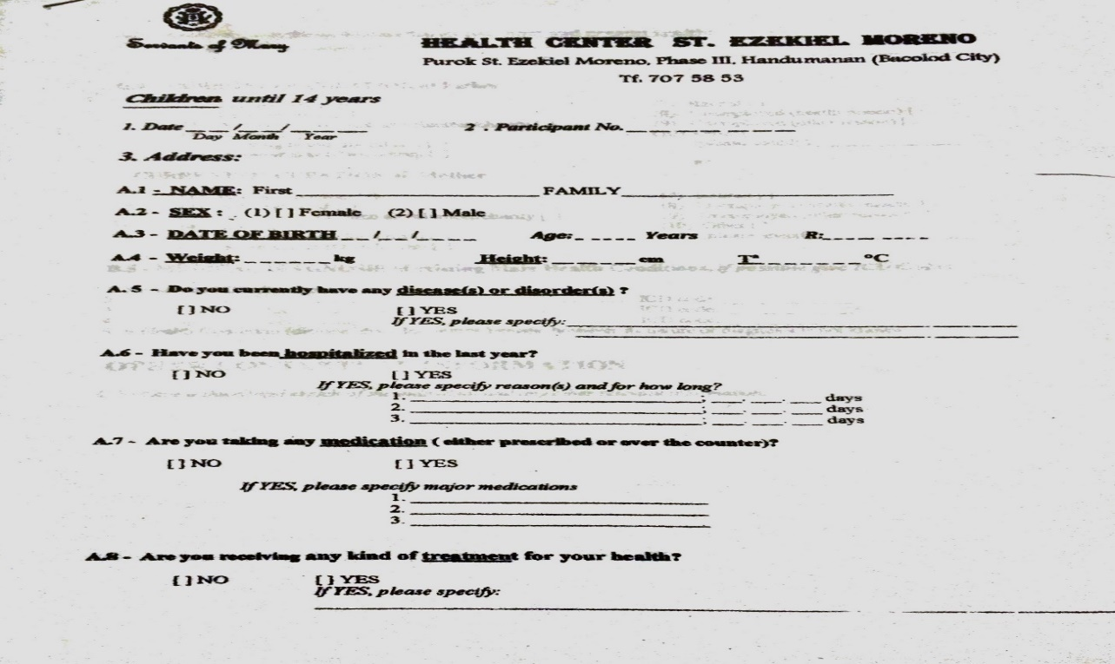

Figure 7. Registration Form for Children (14 years old and below – page 1).

Figure 8 show the second and third page of the registration form for children of 14 years old and below includes the current occupation of the father and mother, past and present health information of the patient, medical diagnosis of the main health condition, relevant information, diagnostic treatment date, and diagnostic treatment description.

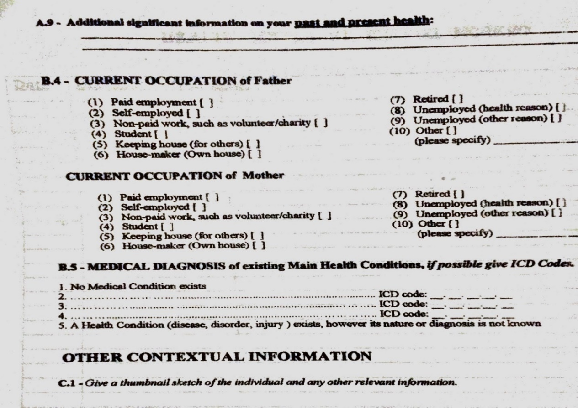

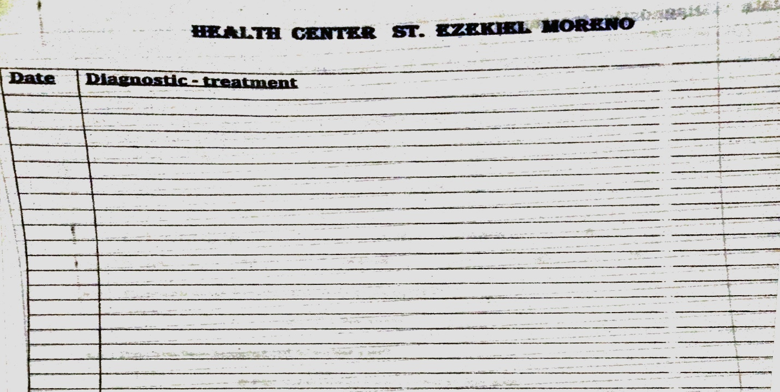

Figure 8. Registration Form for Children (14 years old and below).

3.1.2 Registration Form for Adults.

Figure 9 show the first page of the registration form for adults. It has a similar layout with the registration form for children aged under 14 years old. Except that it some questions regarding to the patient’s dominant hand, physical health, mental and emotional health, and significant injuries. In addition, there is that fourth page that has a format same with figure 8 that shows the diagnostics and treatment of the patient.

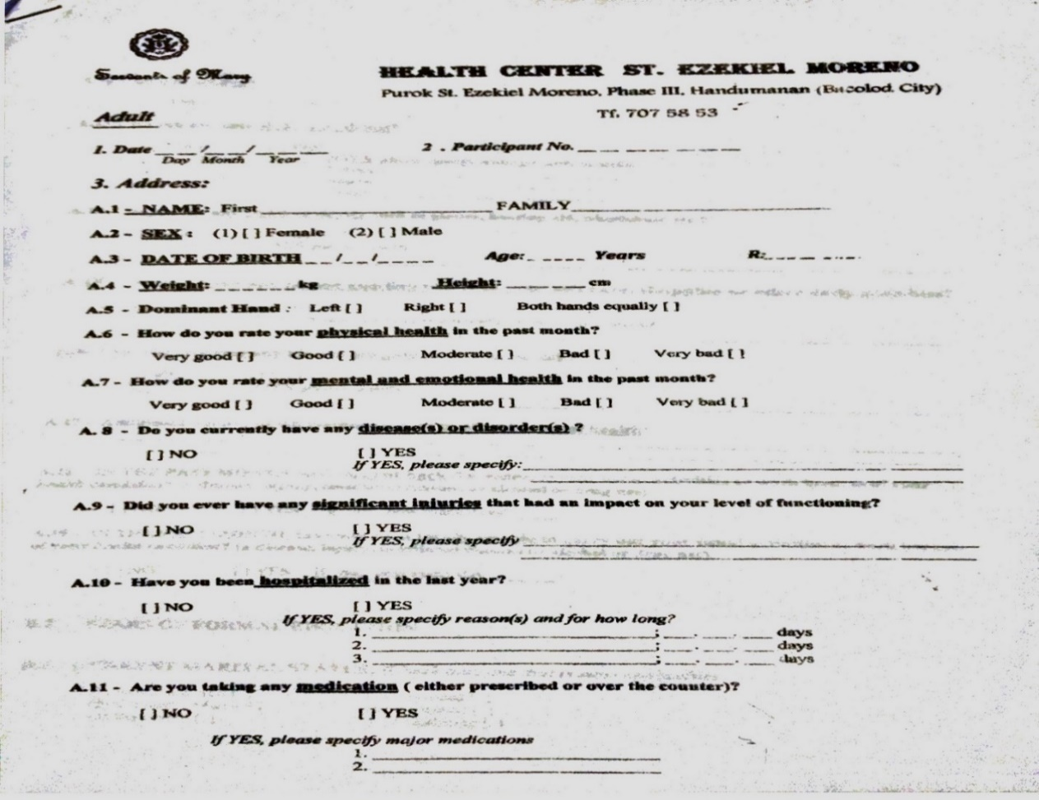

Figure 9. Registration Form (Adults) – page 1.

Figure 10 show the second and third page of the registration form for adults includes the current occupation to whom support the family and the current occupation of the patient, current marital status, years of formal education, cut back health condition and totally unable health condition of the past month, treatment receive, person assisting the patient, assistive device use, alcohol or drug question and smoke question, past and present health information of the patient, medical diagnosis of the main health condition, relevant information, diagnostic treatment date, and diagnostic treatment description.

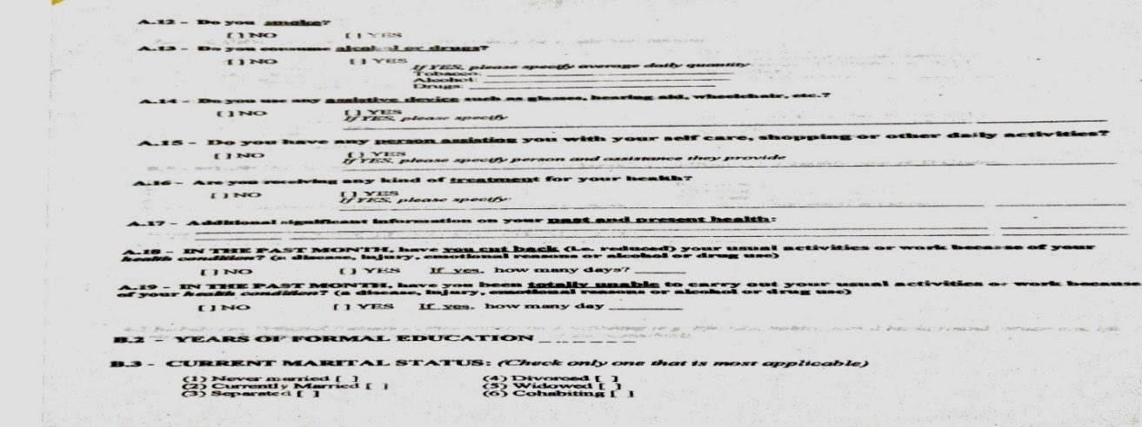

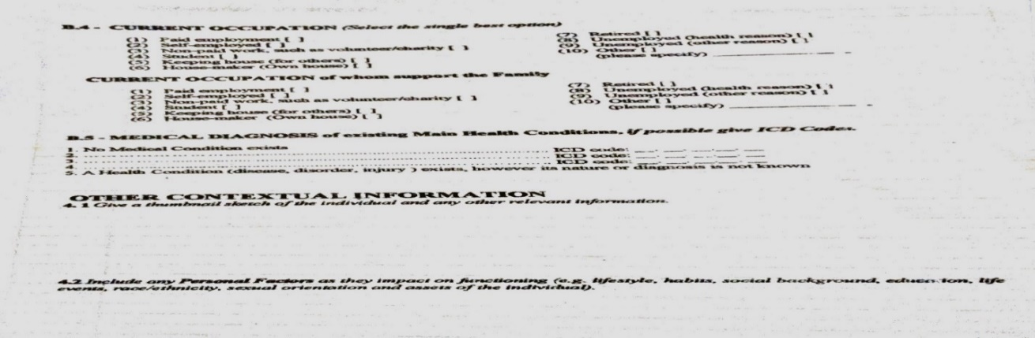

Figure 10. Registration Form (Adults) – pages 2 and 3.

3.1.3 Prescription Slip.

Figure 11 describes the prescription slip that the doctor presents to the patient after the consultation. The prescription slip is used by the doctor to prescribe medicine as well as a referral slip to a specialist if the patient is in need of further treatment.



Figure 11. Prescription Slip.

3.1.4 Hematology Report Form.

Figure 12 describes the hematology results form. The information is gathered from the patient during the lab study. It includes patient information as well as CBC hematocrit, hemoglobin and the differential count that includes segmenters, stabs, eosinophils, lymphocytes, monocytes, basophils, myelocytes, juveniles, platelet count and blood type. These results are shown to the doctor if the patient is in need of a referral to a specialist.

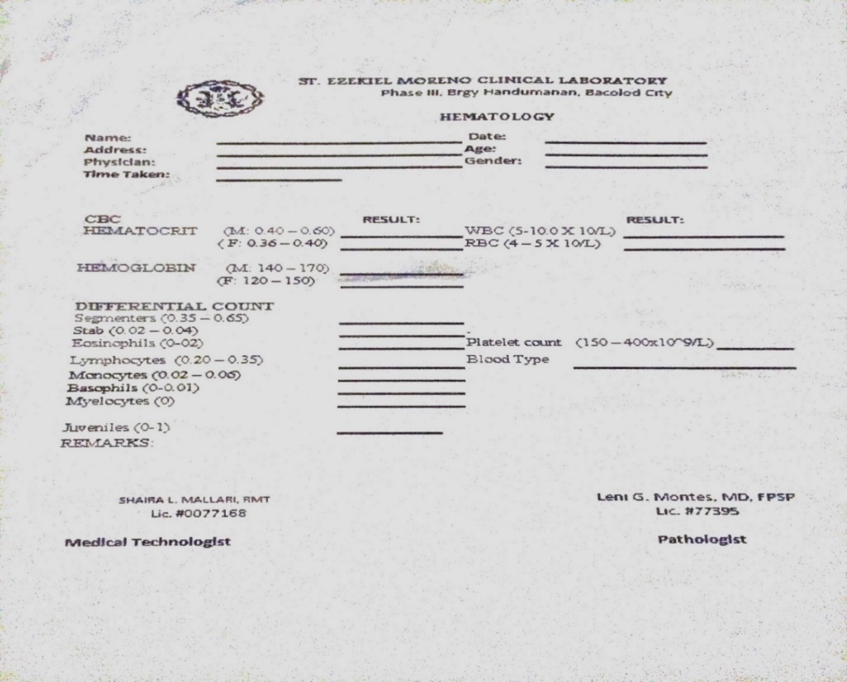

Figure 12. Hematology Report Form.

3.1.5 Fecalysis Report Form.

Figure 13 describes the fecal reports. The information is gathered from the patient during the lab study It includes patient information as well as macroscopic section examination which includes color, consistency and heiminths Parasites section include ascaris, hookworm, trichuris and strongyloides. The chemical test section includes the occult blood while the microscopic examination includes pus cells and RBC. The amoeba section has information regarding to histolytica and coil with cyst and troph. Lastly, information regarding flagellates and its lambia and hominis.

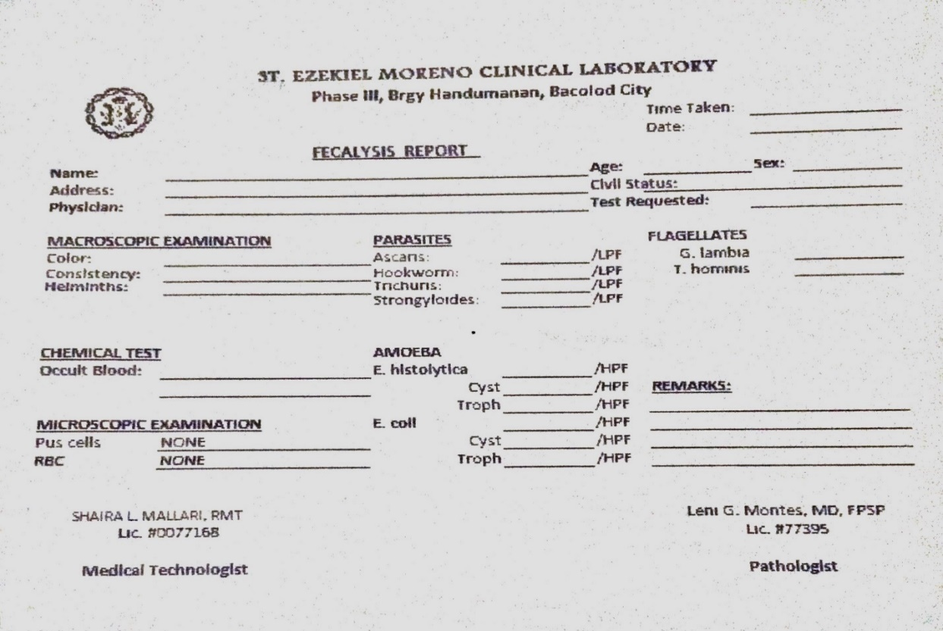

Figure 13. Fecalysis Report Form.

3.1.6 Blood Chemistry.

Figure 14 describes the blood chemistry of the patient. It includes patient information and its examination that is shown in both international and conventional units. The information shown about the blood chemistry is as follows: bun, cholesterol, creatinine, fasting blood sugar(FBS), high-density lipoproiten(HDL)-cholesterol, low-density lipoprotien(LDL)-cholesterol, 2 hours post-prandial, ribosome-binding site(RBS), serume glutamic-oxaloacetic transaminase/aspartate aminotransferase(SGOT/AST), serum glutamic transaminase/alanine aminotransferase(SGPT/ALT), triglyceride and uric acid.

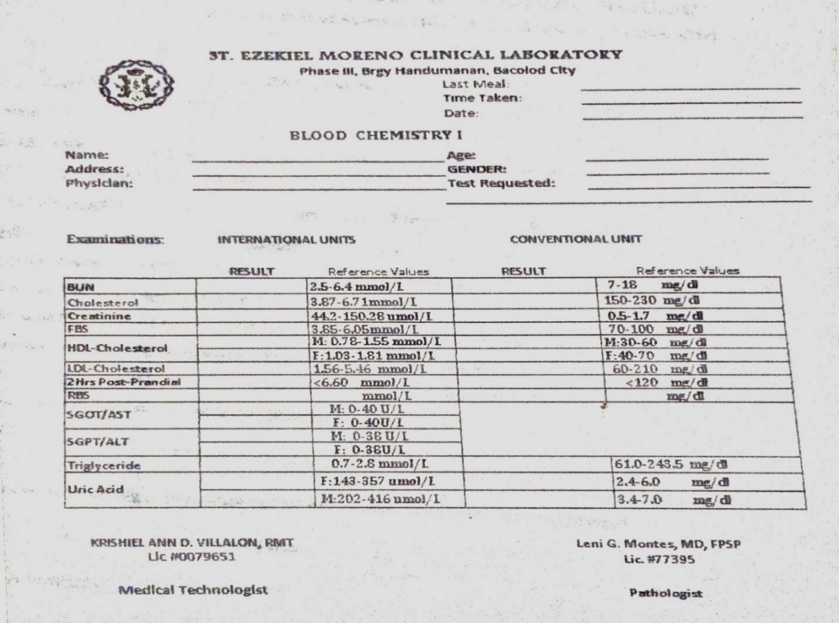

Figure 14. Blood Chemistry Form.

3.1.7 Urinalysis Report Form.

Figure 15 describes the urinalysis report of the patient. It includes patient information and physical properties which includes the color, transparency, ph and specific gravity. The chemical test includes reducing sugar and protein. Th cell shows the PUS, RBC, yeast, squamous renal and bacteria. The casts include DESA, course granular, fine granular, PUS, RBC and waxy. The crystals include information about the amorphous urates, amorphous PO4, uric acid, calcium oxalate, and triple PO4. There are other information provided like the mucus threads and remarks if the doctor has any comments or suggestions to the patient.

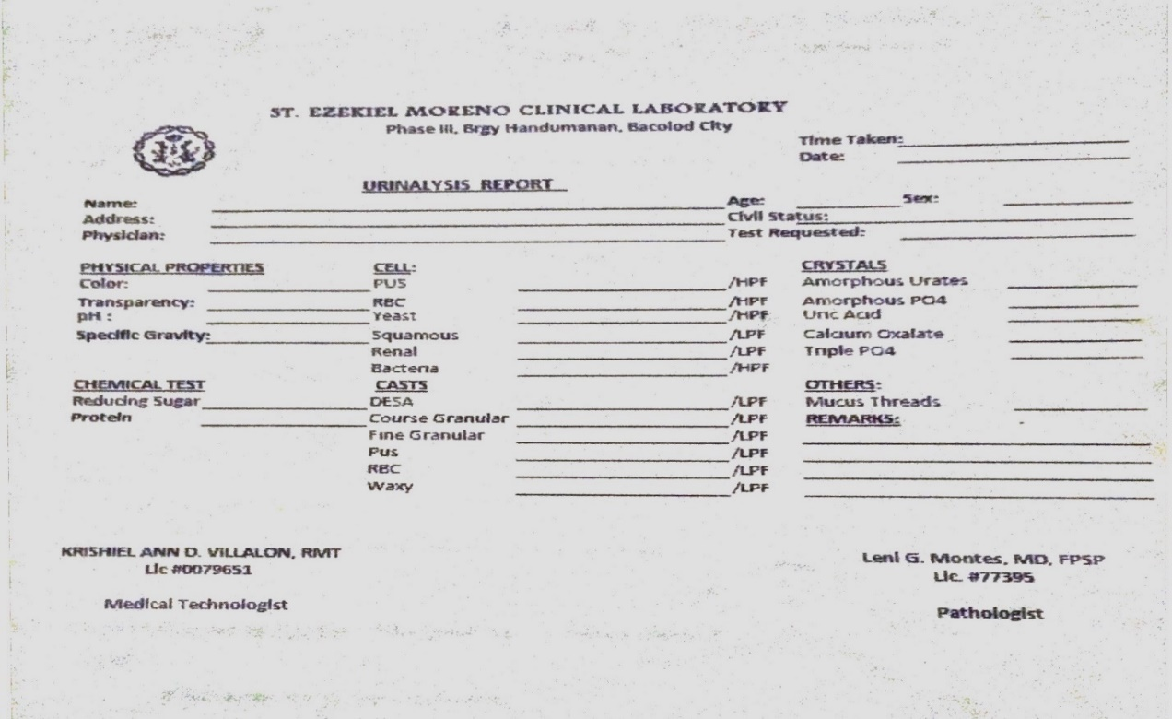

Figure 15. Urinalysis Report Form.

* 1. Data Analysis

There are problems imminent in the current flow of work in the organization. Problems in the organization include manual transfer of files from one department to another. The current automated system requires the patient to register every consultation. This problem affects the memory storage and cause data redundancy.

The said organization has some problems that are need of probable solutions. One of the problems of the organization is that they have only one department that has an automated system but it is still not efficient because some features of the system doesn’t work. Other than that, the organization needs to connect the laboratory and registration area and it is assumed that the system the organization is incomplete. Other departments still use the manual process which takes time in gathering of patient information.

The probable solution to the findings are discussed in this section. The automation of the whole organization allows the medical staff to communicate effectively and pass important files from one department to the other with just using the system. The system storage is accessible to all departments, which means that every personel in every department has access to the files needed to be processed without any delays.

The team gathered some forms, analyzed each of it and concluded that each form is used to acquire the patient’s personal information, fecal, hematology, urinalysis and blood reports. These forms are then used to be based in creating laboratory results for the patient if the patient is in need of further treatment. Information regarding the referral on a specialist is written on the prescription slip as well as the status of the patient if he has indeed paid in the pharmacy for the laboratory test. The team decided to create a system that would help and improve the current system of the said organization. By implementing the St. Ezekiel Moreno Healthcare Management System, the organization can effectively acquire patient details, process and store it in a storage where it is accessible to all departments.

The entity relationship diagram of St. Ezekiel Moreno Healthcare Management includes 19 tables, and each table contains primary key and a foreign key that connected to its related table/s which is shown in Figure 16. The tables are as follows: patient, patient medical issue, adult, consultation, laboratory test, medical record, physician, treatment, urinalysis, hematology, blood chemistry, blood examination, fecalysis, schedule, supplier, services, MedTech, pathologist, and medicine. The entity-relationship diagram of the system is that the physician table is connected with the consultation transaction table. The physician has a user account that connected in the consultation transaction in order to get the personal information of the patient recorded in the system to be based on the recommendation whether if the patient is suggested with the different department services. The medicine list is depending on the consultation of the physician if the patient is required to ask medicine in the pharmacy. The process is when the patient enters the health center, the personal information and the findings in check-up is recorded in the system. After recording of information, the data of the patient is sent to schedule table then to the physician for the analysis. In the consultation table, the doctor recommends the patient if the patient is suggested to undergo laboratory test then the data of the patient is sent to the laboratory department, all of the information during the consultation is stored in the medical record table. The laboratory test table is connected to four tables which are the fecalysis, hematology, urinalysis, and blood chemistry table. The blood examination table is used to store all the examination results for the blood chemistry report. Details about the data fields of the different tables of the ERD is seen in section 3.3 or data dictionary.

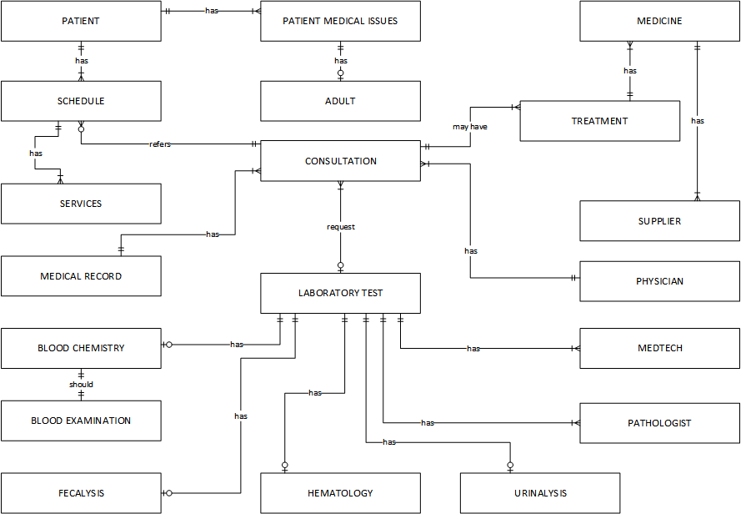

Figure 16. Entity-Relationship Diagram of SEMHMS.

3.3 Data Dictionary

In this subchapter, the data dictionary is discussed as well as the table being described depending on the attributes and its relationship. There are 16 tables and each table can have a relationship to another table.

Table 1 shows the patient table. It has thirteen attributes that include the patient identifier as the primary key, first name, last name, gender, age, birthday, weight, height, type of patient, address, civil status, date of registration, and temperature readings.

|  |  |  |  |  |  |  |  |  |  |  |
| --- | --- | --- | --- | --- | --- | --- | --- | --- | --- | --- |
| Entity Name | Patient | Source Document | | Children Registration Form, Adult Registration Form | | | | | | |
| Entity Description | The Patient entity provides the different attributes relating to Patients’ data required by the activities or processes. | | | | | | | | | |
| Type of Use | ☑ File / Internal ☑ Screen Layout / Form ☑ Report | | | | | | | | | |
| Process(s) Used | Data Entry, Scheduling, Laboratory Test, Consultation Process, Report Generation | | Triggered by | | Patient, Desk Officer | | | Data Store | | Patient.dbf |
| Fieldname | Description | | | | | Type | Length | | Format | |
| P_ID | Patient Identifier | | | | | C | 5 | | A9999 | |
| P_LNAME | Last name of the Patient | | | | | A | 20 | | A(20) | |
| P_FNAME | First name of the patient | | | | | A | 20 | | A(20) | |
| P_GNDR | Gender of the patient | | | | | A | 6 | | A(6) | |
| P_BDATE | Patient date of birth | | | | | D | 8 | | mm/dd/yyyy | |
| P_AGE | Age of the Patient | | | | | N | 2 | | 99 | |
| P_WGHT | Weight of the patient | | | | | N | 3 | | 999 | |
| P_HGHT | Height of the Patient | | | | | N | 3 | | 999 | |
| P_TEMP | Temperature of the Patient | | | | | N | 2 | | 99 | |
| P_TYPE | Type of Patient (Children or Adult) | | | | | A | 8 | | A(8) | |
| P_ADD | Address of the Patient | | | | | A | 30 | | A(30) | |
| P_CVL_STAT | Civil Status of the Patient | | | | | A | 10 | | A(10) | |
| DATE_REG | Date of Registration | | | | | D | 8 | | mm/dd/yyyy | |

Table 1. Patient.

Table 2 shows the patient medical issue table. The attributes are as follows: patient medical issue identifier, patient identifier, medical diagnosis ICD Code of main health condition, past and present health information, treatment received by the patient, medication taken by the patient, current disease or disorder of the patient, hospitalized, and other relevant information of the patient. The form used to construct this table are the children registration form and adult registration form. The patient and desk officer are the one who triggers the patient medical issue table. The patient table and the adult have a relationship to this table. Both foreign keys are needed to make up the patient medical issues table.

|  |  |  |  |  |  |  |  |  |  |  |
| --- | --- | --- | --- | --- | --- | --- | --- | --- | --- | --- |
| Entity Name | Patient Medical Issue | Source Document | | | Children Registration Form, Adult Registration Form | | | | | |
| Entity Description | The Patient Medical Issue entity provides the different attributes relating to Patients’ previous medical issues data required by the activities or processes. | | | | | | | | | |
| Type of Use | ☑ File / Internal ☑ Screen Layout / Form ☑ Report | | | | | | | | | |
| Process(s) Used | Data Entry, Consultation Process, Report Generation | | Triggered by | Patient, Desk Officer | | | Data Store | | Patient_Medical_Issue.dbf | |
| Fieldname | Description | | | | | Type | | Length | | Format |
| PMI_ID | Patient Medical Issue Identifier | | | | | C | | 5 | | A9999 |
| P_ID | Patient Identifier | | | | | C | | 5 | | A9999 |
| MDC | Medical Diagnosis ICD Code of Main Health condition | | | | | C | | 5 | | A9999 |
| PP_HEATH | Past and Present Health information | | | | | A | | 30 | | A(30) |
| TRMT | Treatment receive by the patient | | | | | A | | 30 | | A(30) |
| MEDCT | Medication taken by the patient | | | | | A | | 30 | | A(30) |
| DISE_DISO | Current Diseases or Disorder of the Patient | | | | | A | | 30 | | A(30) |
| HPTL | Patient Hospitalized last year question | | | | | A | | 30 | | A(30) |
| REL_INFO | Patient other relevant Information | | | | | A | | 50 | | A(50) |
| OCCU_ONE | First occupation of the patient | | | | | A | | 20 | | A(20) |
| OCCU_ONE | Second occupation of the patient | | | | | A | | 20 | | A(20) |

Table 2. Patient Medical Issue.

Table 3 shows the adult table. It has fifteen attributes that includes: Adult Identifier as the primary key of the table, patient medical issue identifier, physical health of the patient, mental and emotional health of the patient, significant injuries, assistive device use by the patient, person assisting the patient, marital status, years of formal education, questions if the patient consume alcohol or drugs and smoke, personal factors, dominant hand of the patient, cut back and totally unable health condition of the patient in the past month. The process used by this table is for data entry, scheduling, consultation process, and report generation. All the information that is gathered from this table are stored in the adult data store. The form that is use to construct this table is the adult registration form. It has one foreign key which is the patient identifier from the patient table.

|  |  |  |  |  |  |  |  |  |  |
| --- | --- | --- | --- | --- | --- | --- | --- | --- | --- |
| Entity Name | Adult | Source Document | | | | Adult Registration Form | | | |
| Entity Description | This entity provides the different attributes that is only applicable for an adult patient | | | | | | | | |
| Type of Use | ☑ File / Internal ☑ Screen Layout / Form ☑ Report | | | | | | | | |
| Process(s) Used | Data Entry, Scheduling, Consultation, Report Generation | | Triggered by | Patient, Desk Officer | | | Data Store | | Adult.dbf |
| Fieldname | Description | | | Type | Length | | | Format | |
| ADULT_ID | Adult Identifier | | | C | 5 | | | A9999 | |
| PMI_ID | Patient Medical Issue Identifier | | | C | 5 | | | A9999 | |
| PHY_HEALTH | Physical Health of the patient in the past month | | | A | 10 | | | A(10) | |
| MENT_EMO_HEAl | Mental and Emotional Health of the patient | | | A | 10 | | | A(10) | |
| SIG_INJ | Significant Injuries of the patient | | | A | 30 | | | A(30) | |
| SMOKE | Smoke question for the patient | | | A | 3 | | | A(3) | |
| ALCO_DRUGS | Alcohol or drugs question for the patient | | | A | 3 | | | A(3) | |
| ASSIST_DEV | Assistive Device use by the patient | | | A | 20 | | | A(20) | |
| PERS_ASSIST | Person Assisting the patient question | | | A | 20 | | | A(20) | |
| MARITAL_STAT | Marital Status of the patient | | | A | 10 | | | A(10) | |
| YEARS_FE | Years of Formal Education | | | N | 2 | | | 99 | |
| PERSONAL_FACT | Personal Factors | | | A | 50 | | | A(50) | |
| DOM_HAND | Dominant Hand of the patient | | | A | 5 | | | A(5) | |
| CB_HEALTH_COND | Cut back health Condition in the past month | | | A | 3 | | | A(3) | |
| TU_HEALTH_COND | Totally unable health Condition | | | A | 3 | | | A(3) | |

Table 3. Adult.

Table 4 shows the laboratory test table. It has six attributes that include: Laboratory test identifier, physician identifier, consultation identifier, time taken, test requested, and date. Two are considered foreign keys mainly physician identifier and consultation identifier from physician and consultation tables. The forms that are used to construct this table are the fecalysis, hematology, urinalysis, and blood chemistry form. All the data that is be gathered by this table are stored in the laboratory test database of the system.

|  |  |  |  |  |  |  |  |  |  |  |
| --- | --- | --- | --- | --- | --- | --- | --- | --- | --- | --- |
| Entity Name | Laboratory Test | | Source Document | | | Laboratory Forms | | | | |
| Entity Description | The Laboratory Test entity provides the different attributes relating to laboratory test data required by the activities or processes. | | | | | | | | | |
| Type of Use | ☑ File / Internal ☑ Screen Layout / Form ☑ Report | | | | | | | | | |
| Process(s) Used | Data Entry, Report Generation | Triggered by | | Physician | | | | Data Store | | Laboratory_test.dbf |
| Fieldname | Description | | | | Type | | Length | | Format | |
| LAB_ID | Laboratory Test Identifier | | | | C | | 5 | | A9999 | |
| MDTEC_ID | Medical Technologist Identifier | | | | C | | 5 | | A9999 | |
| PTHGST_ID | Pathologist identifier | | | | C | | 5 | | A9999 | |
| CO_ID | Consultation Identifier | | | | C | | 5 | | A9999 | |
| TIME_TAKEN | Time Taken | | | | D | | 8 | | hh:mm:ss | |
| TEST_REQ | Test requested | | | | A | | 10 | | A(10) | |
| DATE | Date | | | | D | | 8 | | mm/dd/yyyy | |

Table 4. Laboratory Test.

Table 5 shows the physician table. It has four attributes that include physician identifier as the primary key of the table, physician name, specialty, and license number of the physician. The form that is used to construct this table is from the laboratory results form in the organization All information of the physician are stored in the physician database of the system.

|  |  |  |  |  |  |  |  |  |
| --- | --- | --- | --- | --- | --- | --- | --- | --- |
| Entity Name | Physician | | Source Document | | Laboratory Results forms | | | |
| Entity Description | The Physician entity provides the different attributes relating to physician data required by the activities or processes. | | | | | | | |
| Type of Use | ☑ File / Internal ☑ Screen Layout / Form ☑ Report | | | | | | | |
| Process(s) Used | Data Entry | Triggered by | | None | | Data Store | | Physician.dbf |
| Fieldname | Description | | | Type | Length | | Format | |
| PHYSICIAN_ID | Physician Identifier | | | C | 5 | | A9999 | |
| PHYSICIAN_NAME | Physician name | | | A | 30 | | A(30) | |
| SPECIALTY | Specialty of the physician | | | A | 20 | | A(20) | |
| LICENSE_NO | License number of the physician | | | C | 10 | | A999999999 | |

Table 5. Physician.

Table 6 shows the consultation table. It has five attributes that include consultation identifier as the primary key, schedule identifier, physician identifier, consultation remarks, and date. Two foreign key which is the schedule identifier from the schedule table and physician identifier form the physician table. All the data that are gathered by this table is stored in the consultation database of the system.

|  |  |  |  |  |  |  |  |  |  |
| --- | --- | --- | --- | --- | --- | --- | --- | --- | --- |
| Entity Name | Consultation | Source Document | | | Children and Adult Registration form | | | | |
| Entity Description | The consultation entity provides the different attributes relating to consultation data required by the activities or processes. | | | | | | | | |
| Type of Use | ☑ File / Internal ☑ Screen Layout / Form ☑ Report | | | | | | | | |
| Process(s) Used | Data Entry, Scheduling | Triggered by | Patient | | | Data Store | | Consultation.dbf | |
| Fieldname | Description | | | Type | | | Length | | Format |
| CO_ID | Consultation Identifier | | | C | | | 5 | | A9999 |
| SCHEDULE_ID | Schedule Identifier | | | C | | | 5 | | A9999 |
| PHYSICIAN_ID | Physician Identifier | | | C | | | 5 | | A9999 |
| CO_REMARKS | Consultation Remarks | | | A | | | 20 | | A(20) |
| DATE | Date | | | D | | | 8 | | mm/dd/yyyy |

Table 6. Consultation.

Table 7 shows the schedule table. It has 4 attributes that include the schedule identifier as the primary key, patient identifier, schedule date, and schedule purpose. It has one foreign key which is the patient identifier from the patient table. The person who triggers this table is the desk officer from the organization and all the data that are gathered by this table is stored in the schedule data store.

|  |  |  |  |  |  |  |  |
| --- | --- | --- | --- | --- | --- | --- | --- |
| Entity Name | Schedule | | Source Document | | | N/A | |
| Entity Description | The schedule entity allows the patient to be consulted base on their consultation schedule | | | | | | |
| Type of Use | ☑ File / Internal ☑ Screen Layout / Form ☑ Report | | | | | | |
| Process(s) Used | Data Entry | Triggered by | Desk Officer | | Data Store | | Schedule.dbf |
| Fieldname | Description | | Type | Length | | Format | |
| SCHEDULE_ID | Schedule Identifier | | C | 5 | | A9999 | |
| PATIENT_ID | Patient Identifier | | C | 5 | | A9999 | |
| SCHEDULE_DATE | Schedule Date | | D | 8 | | mm/dd/yyyy | |
| SCHEDULE_PURPOSE | Schedule Purpose | | A | 15 | | A(15) | |

Table 7. Schedule.

Table 8 shows the treatment table. It has four attributes that include treatment identifier, consultation identifier, medicine identifier, and diagnostic details. Two are considered foreign keys mainly consultation identifier from the consultation table and medicine identifier from the medicine table. The forms that are used to construct this table are the children and adult registration form.

|  |  |  |  |  |  |  |  |  |  |
| --- | --- | --- | --- | --- | --- | --- | --- | --- | --- |
| Entity Name | Treatment | | Source Document | | Children and Adult Registration form | | | | |
| Entity Description | The treatment entity records all the treatment that had been done. | | | | | | | | |
| Type of Use | ☑ File / Internal ☑ Screen Layout / Form ☑ Report | | | | | | | | |
| Process(s) Used | Data Entry | Triggered by | | Doctor | | | Data Store | | treatment.dbf |
| Fieldname | Description | | | Type | | Length | | Format | |
| TRMT_ID | Treatment Identifier | | | C | | 5 | | A9999 | |
| CO_ID | Consultation Identifier | | | C | | 5 | | A9999 | |
| MEDICINE_ID | Medicine Identifier | | | C | | 5 | | A9999 | |
| DIAGNOSTIC_DETAILS | Diagnostic Details | | | A | | 30 | | A(30) | |

Table 8. Treatment.

Table 9 shows the medical record table. It has three attributes that include medical record as the primary key, consultation identifier, and date. It has one foreign key which is the consultation identifier from the consultation table. The forms that are used to construct this table are the children and adult registration form and prescription form.

|  |  |  |  |  |  |  |
| --- | --- | --- | --- | --- | --- | --- |
| Entity Name | Medical Record | Source Document | | Children and Adult registration form, prescription form | | |
| Entity Description | The Medical record allows the user to store all the information that has been gathered during the consultation. | | | | | |
| Type of Use | ☑ File / Internal ☑ Screen Layout / Form ☑ Report | | | | | |
| Process(s) Used | Data Entry | Triggered by | Desk Officer | | Data Store | Medical_record.dbf |
| Fieldname | Description | | Type | | Length | Format |
| MR_ID | Medical Record Identifier | | C | | 5 | A9999 |
| CO_ID | Consultation Identifier | | C | | 5 | A9999 |
| DATE | Date | | D | | 8 | mm/dd/yyyy |

Table 9. Medical Record.

Table 10 shows the blood chemistry table. It has three attributes which include blood chemistry identifier as the primary key and laboratory test identifier. This table is connected to the laboratory transaction table. One foreign key which is the laboratory identifier from the laboratory test table and the form that is used to construct this table is the blood chemistry report form.

|  |  |  |  |  |  |  |  |  |
| --- | --- | --- | --- | --- | --- | --- | --- | --- |
| Entity Name | Blood Chemistry | | Source Document | | | | | Blood chemistry report form |
| Entity Description | The blood chemistry entity stores all the blood chemistry laboratory results data. | | | | | | | |
| Type of Use | ☑ File / Internal ☑ Screen Layout / Form ☑ Report | | | | | | | |
| Process(s) Used | Data Entry, Generation of reports | Triggered by | Doctor | | Data Store | | Blood_chemistry.dbf | |
| Fieldname | Description | | Type | Length | | Format | | |
| BLD_CHEM_ID | Blood Chemistry Identifier | | C | 5 | | A9999 | | |
| LAB_ID | Laboratory Test Identifier | | C | 5 | | A9999 | | |
| DATE | Date | | D | 8 | | mm/dd/yyyy | | |

Table 10. Blood Chemistry.

Table 11 shows the blood examination table. It has 27 attributes which include blood examination identifier which serves as the primary key and blood chemistry identifier as the foreign key from the blood chemistry table. In this table, there are two types of blood examination unit, the international and conventional unit which holds different amount of result of the following results. The form used to construct this table is the blood chemistry report form from the laboratory in the organization, it also helps to the creation of the screen layout of the system and all data that has been gathered by this table are stored in the blood examination database of the system and is used for reports generation.

|  |  |  |  |  |  |  |  |  |  |  |
| --- | --- | --- | --- | --- | --- | --- | --- | --- | --- | --- |
| Entity Name | Blood Examination | | Source Document | | | | | Blood chemistry report form. | | |
| Entity Description | The blood examination entity provides all the result of the blood examination for the blood chemistry laboratory test. | | | | | | | | | |
| Type of Use | ☑ File / Internal ☑ Screen Layout / Form ☑ Report | | | | | | | | | |
| Process(s) Used | Data Entry, generation of reports. | Triggered by | | Doctor | | Data Store | | | | Blood_examination.dbf |
| Fieldname | Description | | | | Type | | Length | | Format | |
| BL_EXM_ID | Blood Examination Identifier | | | | C | | 5 | | A9999 | |
| BLD_CHEM_ID | Blood Chemistry Identifier | | | | C | | 5 | | A9999 | |
| BUN_ETYPE_INT | BUN Examination Type International Unit | | | | N | | 4 | | 9999 | |
| CRTN_ETYPE_INT | Creatinine Examination type International Unit | | | | N | | 4 | | 9999 | |
| FBS_ETYPE_INT | FBS Examination type International Unit | | | | N | | 4 | | 9999 | |
| HDL_M_ETYPE_INT | HDL-Cholesterol for Male Examination type International Unit | | | | N | | 4 | | 9999 | |
| HDL_F_ETYPE_INT | HDL-Cholesterol for Female Examination type International Unit | | | | N | | 4 | | 9999 | |
| LDL_ETYPE_INT | LDL-Cholesterol Examination type International Unit | | | | N | | 4 | | 9999 | |
| PO_PR_ETYPE_INT | 2 Hrs Post-Prandial Examination type International Unit | | | | N | | 4 | | 9999 | |
| RBS_ETYPE_INT | RBS Examination type International Unit | | | | N | | 4 | | 9999 | |
| SGOT_M_ETYPE_INT | SGOT/AST for Male Examination type International Unit | | | | N | | 4 | | 9999 | |
| SGOT_F_ETYPE_INT | SGOT/AST for Female Examination type International Unit | | | | N | | 4 | | 9999 | |
| SGPT_M_ETYPE_INT | SGPT/ALT for Male Examination type International Unit | | | | N | | 4 | | 9999 | |
| SGPT_F_ETYPE_INT | SGPT/ALT for Female Examination type International Unit | | | | N | | 4 | | 9999 | |
| TRLYDE _ETYPE_INT | Triglyceride Examination type International Unit | | | | N | | 4 | | 9999 | |
| URIC_M_ETYPE_INT | Uric Acid for Male Examination type International Unit | | | | N | | 4 | | 9999 | |
| URIC_M_ETYPE_INT | Uric Acid for Female Examination type International Unit | | | | N | | 4 | | 9999 | |
| BUN_ETYPE_CON | BUN Examination Type Conventional Unit | | | | N | | 4 | | 9999 | |
| CRTN_ETYPE_CON | Creatinine Examination type Conventional Unit | | | | N | | 4 | | 9999 | |
| FBS_ETYPE_CON | FBS Examination type Conventional Unit | | | | N | | 4 | | 9999 | |
| HDL_M_ETYPE_CON | HDL-Cholesterol for Male Examination type Conventional Unit | | | | N | | 4 | | 9999 | |
| HDL_F_ETYPE_CON | HDL-Cholesterol for Female Examination type Conventional Unit | | | | N | | 4 | | 9999 | |
| LDL_ETYPE_CON | LDL-Cholesterol Examination type Conventional Unit | | | | N | | 4 | | 9999 | |
| PO_PR_ETYPE_CON | 2 Hrs Post-Prandial Examination type Conventional Unit | | | | N | | 4 | | 9999 | |
| RBS_ETYPE_CON | RBS Examination type Conventional Unit | | | | N | | 4 | | 9999 | |
| TRLYDE_ETYPE_CON | Triglyceride Examination type Conventional Unit | | | | N | | 4 | | 9999 | |
| URIC_M_ETYPE_CON | Uric Acid for Male Examination type Conventional Unit | | | | N | | 4 | | 9999 | |
| URIC_M_ETYPE_CON | Uric Acid for Female Examination type Conventional Unit | | | | N | | 4 | | 9999 | |

Table 11. Blood Examination.

Table 12 shows the medicine table. It has five attributes which include medicine identifier as the primary key, medicine category based on the patient type, medicine description, medicine type, and medicine quantity. It has a foreign key which is the supplier identifier which is from the supplier table. It is triggered by the pharmacist in the organization and all the data that has been gathered by this table are stored in the medicine database of the system.

|  |  |  |  |  |  |  |  |  |  |
| --- | --- | --- | --- | --- | --- | --- | --- | --- | --- |
| Entity Name | Medicine | Source Document | | | | | | N/A | |
| Entity Description | The medicine entity provides all the list of the medicine information | | | | | | | | |
| Type of Use | ☑ File / Internal ☑ Screen Layout / Form ☑ Report | | | | | | | | |
| Process(s) Used | Data Entry, generation of report | | Triggered by | | pharmacist | | Data Store | | Medicine.dbf |
| Fieldname | Description | | | Type | | Length | | Format | |
| MEDICINE_ID | Medicine Identifier | | | C | | 5 | | A9999 | |
| SUP_ID | Supplier Identifier | | | C | | 5 | | A9999 | |
| MEDICINE_CAT | Medicine Category based on the Patient type | | | A | | 8 | | A(8) | |
| MEDICINE_DESC | Medicine Description | | | A | | 20 | | A(20) | |
| MEDICINE_TYPE | Medicine Type | | | A | | 15 | | A(15) | |
| MEDICINE_QTY | Medicine Quantity | | | N | | 4 | | 9999 | |

Table 12. Medicine.

Table 13 shows the fecalysis table. It has 21 attributes which include fecalysis identifier that serves as the primary key and the laboratory identifier as the foreign key which is from the laboratory test table and the form that is used to construct this table is the fecalysis report form from the laboratory department of the organization. All the data gathered by this table are stored in the fecalysis database of the system and is used for reports generation.

|  |  |  |  |  |  |  |  |  |  |  |
| --- | --- | --- | --- | --- | --- | --- | --- | --- | --- | --- |
| Entity Name | Fecalysis | | Source Document | | | | | Fecalysis report form. | | |
| Entity Description | The fecalysis entity provides all the result for the fecalysis laboratory test. | | | | | | | | | |
| Type of Use | ☑ File / Internal ☑ Screen Layout / Form ☑ Report | | | | | | | | | |
| Process(s) Used | Data Entry, generation of reports. | Triggered by | | Doctor | | Data Store | | | Fecalysis.dbf | |
| Fieldname | Description | | | | Type | | Length | | | Format |
| FECAL_ID | Fecalysis Identifier | | | | C | | 5 | | | A9999 |
| LAB_ID | Laboratory Test Identifier | | | | C | | 5 | | | A9999 |
| CLR_MCRO_EXM | Macroscopic Examination for Color | | | | A | | 15 | | | A(15) |
| CONS_MCRO_EXM | Macroscopic Examination for Consistency | | | | A | | 10 | | | A(10) |
| HLMT_MCRO_EXM | Macroscopic Examination for Helminths | | | | A | | 10 | | | A(10) |
| PARA_ASCARIS | Ascaris Parasite | | | | C | | 3 | | | 9A9 |
| PARA_HKWORM | Hookworm Parasite | | | | C | | 3 | | | 9A9 |
| PARA_TRHRIS | Trichuris Parasite | | | | C | | 3 | | | 9A9 |
| PARA_STRGLOIDES | Strongyloides Parasite | | | | C | | 3 | | | 9A9 |
| CT_OB | Chemical Test Occult Blood | | | | A | | 10 | | | A(10) |
| PCELLS_MICRO_EXM | Microscopic Examination for Pus cells | | | | A | | 10 | | | A(10) |
| RBC_MCRO_EXM | Microscopic Examination for RBC | | | | A | | 10 | | | A(10) |
| E_AMOEBA_HISTOL | Entamoeba Histolytica | | | | C | | 3 | | | 9A9 |
| E_HISTOL_CYST | Entamoeba Histolytica CYST | | | | C | | 3 | | | 9A9 |
| E_HISTOL_TROPH | Entamoeba Histolytica TROPH | | | | C | | 3 | | | 9A9 |
| E_AMOEBA_COLI | Entamoeba Coli | | | | C | | 3 | | | 9A9 |
| COLI_CYST | Entamoeba Coli CYST | | | | C | | 3 | | | 9A9 |
| COLI_TROPH | Entamoeba Coli TROPH | | | | C | | 3 | | | 9A9 |
| FLAG_G_LAMBIA | Giardia Lambia Flagellates | | | | A | | 5 | | | A(5) |
| FLAG_T_HOMINIS | Trichomonas Hominis Flagellates | | | | A | | 5 | | | A(5) |
| REMARKS | Remarks | | | | A | | 30 | | | A(30) |

Table 13. Fecalysis.

Table 14 shows the supplier table. It has three attributes that include supplier identifier as the primary key of the table, supplier name, and the supplier address. All information of the supplier are stored in the supplier database of the system that is used for reports generations.

|  |  |  |  |  |  |  |  |  |  |  |
| --- | --- | --- | --- | --- | --- | --- | --- | --- | --- | --- |
| Entity Name | Supplier | | Source Document | | | | | N/A | | |
| Entity Description | The supplier entity provides the different attributes relating to supplier data required by the activities or processes. | | | | | | | | | |
| Type of Use | ☑ File / Internal ☑ Screen Layout / Form ☑ Report | | | | | | | | | |
| Process(s) Used | Data Entry | Triggered by | | Pharmacist | | | Data Store | | | Supplier.dbf |
| Fieldname | Description | | | | Type | Length | | | Format | |
| SUP_ID | Supplier Identifier | | | | C | 5 | | | A9999 | |
| SUP_NAME | Supplier Name | | | | A | 30 | | | A(30) | |
| SUP_ADDRESS | Supplier Address | | | | A | 50 | | | A(50) | |

Table 14. Supplier.

Table 15 shows the hematology table. It has 19 attributes that include the hematology identifier serves as the primary key and the laboratory identifier as the foreign key which is from the laboratory test table and the form used to construct this table is the hematology report form of the laboratory department in the organization. All the data that has been gathered are stored in the hematology database of the system.

|  |  |  |  |  |  |  |  |  |  |  |
| --- | --- | --- | --- | --- | --- | --- | --- | --- | --- | --- |
| Entity Name | Hematology | | Source Document | | | | | Hematology report form | | |
| Entity Description | The hematology entity provides all the result of the hematology laboratory test. | | | | | | | | | |
| Type of Use | ☑ File / Internal ☑ Screen Layout / Form ☑ Report | | | | | | | | | |
| Process(s) Used | Data Entry, generation of reports. | Triggered by | | Doctor | | Data Store | | | | Hematology.dbf |
| Fieldname | Description | | | | Type | | Length | | Format | |
| HEMA_ID | Hematology Identifier | | | | C | | 5 | | A9999 | |
| LAB_ID | Laboratory Identifier | | | | C | | 5 | | A9999 | |
| HEMA_M_ETYPE_CBC | Hematocrit for Male examination type CBC result | | | | N | | 4 | | 9999 | |
| HEMA_F_ETYPE_CBC | Hematocrit for Female examination type CBC result | | | | N | | 4 | | 9999 | |
| HEMO_M_ETYPE_CBC | Hemoglobin for Male Examination type CBC result | | | | N | | 3 | | 999 | |
| HEMO_F_ETYPE_CBC | Hemoglobin for Female Examination type CBC result | | | | N | | 3 | | 999 | |
| WBC_ETYPE_CBC | White Blood Cells Examination type CBC result | | | | A | | 10 | | A(10) | |
| RBC_ETYPE_CBC | Red Blood Cells Examination type CBC result | | | | A | | 10 | | A(10) | |
| SEG_DIFF_COUNT | Segmenters for Differential Count result | | | | N | | 4 | | 9999 | |
| STAB_DCOUNT | Stab for Differential Count result | | | | N | | 4 | | 9999 | |
| EOSI_DCOUNT | Eosinophils for Differential Count result | | | | N | | 4 | | 9999 | |
| LYMP_DCOUNT | Lymphocytes for Differential Count result | | | | N | | 4 | | 9999 | |
| MONO_DCOUNT | Monocytes for Differential Count result | | | | N | | 4 | | 9999 | |
| BASO_DCOUNT | Basophils for Differential Count result | | | | N | | 4 | | 9999 | |
| MYELO_DCOUNT | Myelocytes for Differential Count result | | | | N | | 1 | | 9999 | |
| PLA_CT_DCOUNT | Platelet Count for Differential Count result | | | | A | | 10 | | A(10) | |
| BLD_TYP_DCOUNT | Blood Type for Differential Count result | | | | C | | 4 | | C(4) | |
| JUVEN_DCOUNT | Juveniles for Differential Count result | | | | N | | 2 | | 99 | |
| REMARKS | Remarks | | | | A | | 30 | | A(30) | |

Table 15. Hematology.

Table 16 shows the urinalysis table. It has 27 attributes that include the urinalysis identifier serves as the primary key and the laboratory identifier as the foreign key which is from the laboratory test table. The form used to construct this table is the urinalysis report form from the laboratory in the organization and all the data that has been collected by this table are stored in the urinalysis database of the system and is used for reports generation.

|  |  |  |  |  |  |  |  |  |  |
| --- | --- | --- | --- | --- | --- | --- | --- | --- | --- |
| Entity Name | Urinalysis | | Source Document | | | | Urinalysis report form. | | |
| Entity Description | The urinalysis entity provides all the result of the urinalysis laboratory test. | | | | | | | | |
| Type of Use | ☑ File / Internal ☑ Screen Layout / Form ☑ Report | | | | | | | | |
| Process(s) Used | Data Entry, generation of reports. | Triggered by | | Doctor | | Data Store | | | Urinalysis.dbf |
| Fieldname | Description | | | Type | Length | | | Format | |
| URINE_ID | Urinalysis Identifier | | | C | 5 | | | A9999 | |
| LAB_ID | Laboratory Test Identifier | | | C | 5 | | | A9999 | |
| COLOR_PHY_PRO | Color Physical Properties Result | | | A | 15 | | | A(10) | |
| TRANS_PHY_PRO | Transparency Physical Properties Result | | | A | 10 | | | A(10) | |
| PH_PHY_PRO | PH Physical Properties Result | | | A | 10 | | | A(10) | |
| SPEC_GRAV_PHY_PRO | Specific Gravity Physical Properties Result | | | N | 5 | | | 99999 | |
| RED_SUG_CT | Reducing Sugar Chemical Test Result | | | N | 5 | | | 99999 | |
| PRO_CT | Protein Chemical Test Result | | | N | 5 | | | 99999 | |
| PUS_CELL | PUS Cell Result | | | A | 10 | | | A(10) | |
| RBC_CELL | RBC Cell Result | | | A | 10 | | | A(10) | |
| YEAST_CELL | Yeast Cell Result | | | A | 10 | | | A(10) | |
| SQUAMOUS_CELL | Squamous Cell Result | | | A | 10 | | | A(10) | |
| RENAL_CELL | Renal Cell Result | | | A | 10 | | | A(10) | |
| BACTERIA_CELL | Bacteria Cell Result | | | A | 10 | | | A(10) | |
| DESA_CASTS | DESA Casts Result | | | A | 10 | | | A(10) | |
| CO_GRAN_CASTS | Course Granular Casts Result | | | A | 10 | | | A(10) | |
| FIN_GRAN_CASTS | Fine Granular Casts Result | | | A | 10 | | | A(10) | |
| PUS_CASTS | PUS Casts Result | | | A | 10 | | | A(10) | |
| RBC_CASTS | RBC Casts Result | | | A | 10 | | | A(10) | |
| WAXY_CASTS | Waxy Casts Result | | | A | 10 | | | A(10) | |
| AU_CRYSTALS | Amorphous Urates Crystals Result | | | A | 10 | | | A(10) | |
| APO_CRYSTALS | Amorphous PO4 Crystals Result | | | A | 10 | | | A(10) | |
| URIC_ACID_CRYSTALS | Uric Acid Crystals Result | | | A | 10 | | | A(10) | |
| CAL_OX_CRYSTALS | Calcium Oxalate Crystals Result | | | A | 10 | | | A(10) | |
| TRI_PO_CRYSTALS | Triple PO4 Crystals Result | | | A | 10 | | | A(10) | |
| MUC_TH | Mucus Threads | | | A | 10 | | | A(10) | |
| REMARKS | Remarks | | | A | 30 | | | A(30) | |

Table 16. Urinalysis.

Table 17 shows the services table. It has two attributes that include service identifier as the primary key of the table and the service description. All information of the services are stored in the service database of the system that is used for reports generation.

|  |  |  |  |  |  |  |  |  |  |  |
| --- | --- | --- | --- | --- | --- | --- | --- | --- | --- | --- |
| Entity Name | Services | | Source Document | | | | | N/A | | |
| Entity Description | The services entity provides the different attributes relating to services data required by the activities or processes. | | | | | | | | | |
| Type of Use | ☑ File / Internal ☑ Screen Layout / Form ☑ Report | | | | | | | | | |
| Process(s) Used | Data Entry | Triggered by | | None | | Data Store | | | | service.dbf |
| Fieldname | Description | | | | Type | | Length | | Format | |
| SRV_ID | Service Identifier | | | | C | | 5 | | A9999 | |
| SRV_Desc | Service Description | | | | A | | 10 | | A(10) | |

Table 17. Services.

Table 18 shows the MedTech table. It has four attributes that include the medical technologist identifier as the primary key, medical technologist name, medical technologist license number, and medical technologist address. This table is connected to the laboratory transaction table and the form used to construct this table is the laboratory result form from the organization. All information of the medical technologist is stored in the MedTech database of the system.

|  |  |  |  |  |  |  |  |  |
| --- | --- | --- | --- | --- | --- | --- | --- | --- |
| Entity Name | Medtech | | Source Document | | Laboratory Results forms | | | |
| Entity Description | The MedTech entity stores all the information of the medical technologist in the organization | | | | | | | |
| Type of Use | ☑ File / Internal ☑ Screen Layout / Form ☑ Report | | | | | | | |
| Process(s) Used | Data Entry. | Triggered by | | none | | | Data Store | Medtech.dbf |
| Fieldname | Description | | | Type | | Length | Format | |
| MDTEC_ID | Medical Technologist Identifier | | | C | | 5 | A9999 | |
| MDTEC_NAME | Medical Technologist Name | | | A | | 30 | A9999 | |
| MDTEC_LCN | Medical Technologist License Number | | | A | | 10 | A(10) | |
| MDTEC_ADD | Medical Technologist Address | | | A | | 50 | A(50) | |

Table 18. Medtech.

Table 19 shows the pathologist table. It has four attributes which include a pathologist Identifier as the primary key, pathologist name, pathologist license number, and pathologist address. This table is connected to the laboratory transaction table and all information of the pathologist are stored in the pathologist database of the system.

|  |  |  |  |  |  |  |  |  |  |
| --- | --- | --- | --- | --- | --- | --- | --- | --- | --- |
| Entity Name | Pathologist | | Source Document | | | Laboratory Results forms | | | |
| Entity Description | The pathologist entity stores all the information of the pathologist in the organization | | | | | | | | |
| Type of Use | ☑ File / Internal ☑ Screen Layout / Form ☑ Report | | | | | | | | |
| Process(s) Used | Data Entry. | Triggered by | | none | | | Data Store | | Pathologist.dbf |
| Fieldname | Description | | | Type | Length | | | Format | |
| PTHGST_ID | Pathologist identifier | | | C | 5 | | | A9999 | |
| PTHGST_NAME | Pathologist Name | | | A | 30 | | | A(30) | |
| PTHGST_LCN | Pathologist License Number | | | A | 10 | | | A(10) | |
| PTHGST_ADD | Pathologist Address | | | A | 50 | | | A(50) | |

Table 19. Pathologist.

This chapter discusses the following forms used by the team for the system. It helps the team construct the ERD in order to determine the logical database design for the system. The team constructed 19 tables for the ERD and all data that has been gathered from the following forms has been normalized in order to improve the system and avoid redundant data.